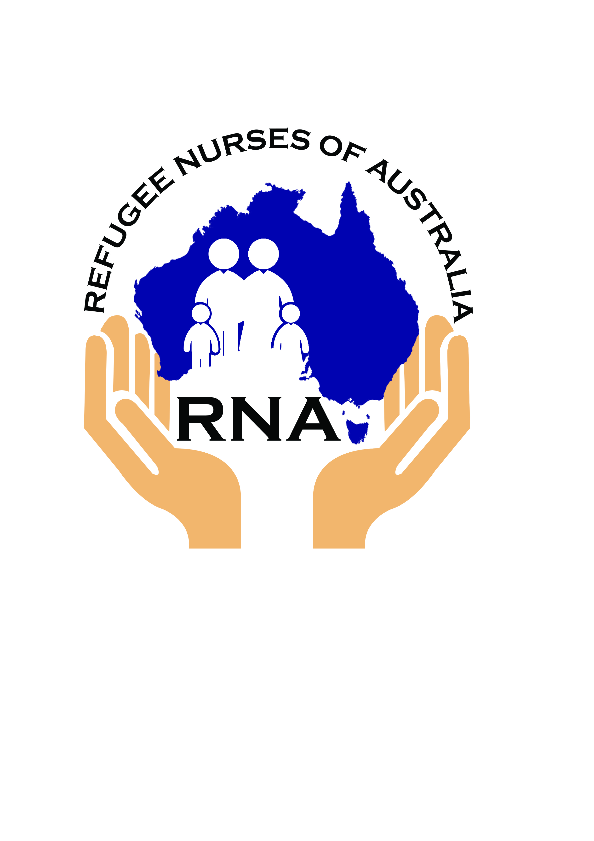
REFUGEE NURSES AUSTRALIA (RNA)
Interstate Transfer Template
For clients from Refugee and Asylum Seeker backgrounds

Description | - Many people from Refugee and Asylum Seeker backgrounds are transitioning between states and territories in Australia.  - To assist the transition of clients and provide support we are asking that the client’s basic contact details be emailed or faxed to the lead nurses in each state.(details on page 2)  - The lead nurses will then email the appropriate Refugee Health Nurses depending on the suburb of the clients’ future settlement  - This referral should not include client medical records which will only be forwarded after a signed ‘consent for release of information’ has been received from the new health care provider.
Client contact details | □ Please tick to indicate client has consented to share contact details  Last name: ……………………………..………………………………………….  First name: ……………………………………………………...… Gender: Male/female  Number of dependents: ……  Suburb (please nominate suburb not major city) /State moving to:  ………………………………………………………………………(NB: not street address)  Approximate date of arrival: ……………….………………….  Contact phone number: ……………………………………………….…..…  Explain to the client that a person from a Refugee Health Program will be contacting them to assist with accessing health services.
Interpreters | Please state if a specific interpreter or gender is required.  Language: …………………………………………….……………………… M / F
Contact details:  1 Nurse  2 Case Manager  3 General Practitioner | 1 Name of referring nurse: …………………………...……………………………………………….  Phone number and Fax number: ……………………………………………………………………  2 Name/organisation of current Settlement case manager:…………………………………………  Email………………………………………………...................................................................................  Phone number ……….…………………………………………….………………………………..…  3 Name/organisation of current General Practitioner: ……………………….………………………  Fax number ………………………………………………………………………………………………  Phone number …………………………………………………………………….…………………..….

Refugee Health Nurse Interstate Contact List
Leeanne Schmidt | CNC Metro South Refugee Health Service | QLD | metrosouth_refugeehealth@health.qld.gov.au | Mob: 0418 769 023  Fax: 07 3808 3193
Meryl Jones | Nurse Unit Manager Mater Refugee Health | QLD | mirhs@mater.org.au | Ph 07 3163 2891  Fax: 07 3163 1969
Sandy Eagar | Nurse Manager NSW Refugee Health Service | NSW | sandy.eagar@health.nsw.gov.au | Mob: 0427 480 033  Fax: 02 8778 0790
Michele Greenwood | Refugee Multicultural Health Clinical Nurse Consultant | NSW | Michele.greenwood@health.nsw.gov.au | Ph: 02 6656 7676
Kath Desmyth | State Wide Facilitator Refugee Health Program | VIC | kath.desmyth@cohealth.org.au | Mob: 0429 044 091
Merilyn Spratling | Refugee Health Nurse Coordinator | VIC | mspratling@each.com.au | Ph 03 9837 3900  Fax: 03 9879 6356
Jan Williams | Nurse Unit Manager  SA Refugee Health Service | SA | jan.williams@sa.gov.au | Ph: 08 8237 3912  Fax:08 8237 3949
Scott Anderson | Refugee Health Coordinator | NT | refugeehealth@melaleuca.org.au | Ph: 08 8985 3311
Lance Jarvis | Clinical Nurse Specialist | WA | MigrantHealth@health.wa.gov.au  Lance.Jarvis@health.wa.gov.au | Ph: 08 9222 8500  Fax 08 9222 8501
Megan Enright | Clinical Nurse Specialist | ACT | megan.enright@companionhouse.org.au | Ph 02 6251 4550
Lou Leol | Clinical Nurse Consultant –Southern Refugee Health Services, Hobart | TAS | lou.leol@ths.tas.gov.au | Ph 03 61666834.  Mob: 0438827016.
Fanou Burslem | Clinical Nurse Consultant Refugee Health Services, Launceston | TAS | fanou.burslem@ths.tas.gov.au | Ph: 03 6777 4367

